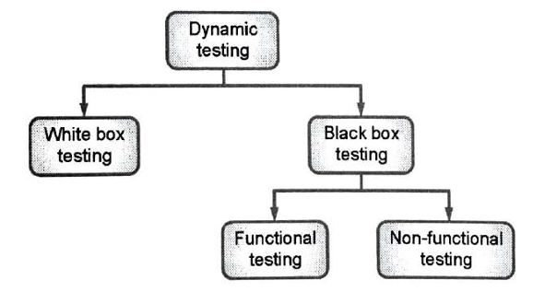

| **Black Box Testing** | **White Box Testing** |
| --- | --- |
| It is a way of software testing in which the internal structure or the program or the code is hidden and nothing is known about it. | It is a way of testing the software in which the tester has knowledge about the internal structure or the code or the program of the software. |
| Implementation of code is not needed for black box testing. | Code implementation is necessary for white box testing. |
| It is mostly done by software testers. | It is mostly done by software developers. |
| No knowledge of implementation and programming is needed. | Knowledge of implementation and programming is required. |
| It can be referred to as outer or external software testing. | It is the inner or the internal software testing. |
| It is a functional test of the software. | It is a structural test of the software. |
| This testing can be initiated based on the requirement specifications document. | This type of testing of software is started after a detail design document. |
| It is the behavior testing of the software. | It is the logic testing of the software. |
| It is applicable to the higher levels of testing of software. | It is generally applicable to the lower levels of software testing. |
| It is also called closed testing, functional testing. | It is also called as clear box testing, glass box testing. |
| It is least time consuming and less exhaustive. | It is most time consuming and more exhaustive. |
| It is not suitable or preferred for algorithm testing. | It is suitable for algorithm testing. |
| Can be done by trial and error ways and methods. | Data domains along with inner or internal boundaries can be better tested. |
| **Example:** Search something on google by using keywords | **Example:** By input to check and verify loops |
| **Types of Black Box Testing:**   * Functional Testing * Non-functional testing * Regression Testing | **Types of White Box Testing:**   * Path Testing * Loop Testing * Condition testing |

Boundary Value Analysis

<https://www.geeksforgeeks.org/software-testing-boundary-value-analysis/>

min-1…Min,more than min, nominal, less than max, max…max+1

4n+1

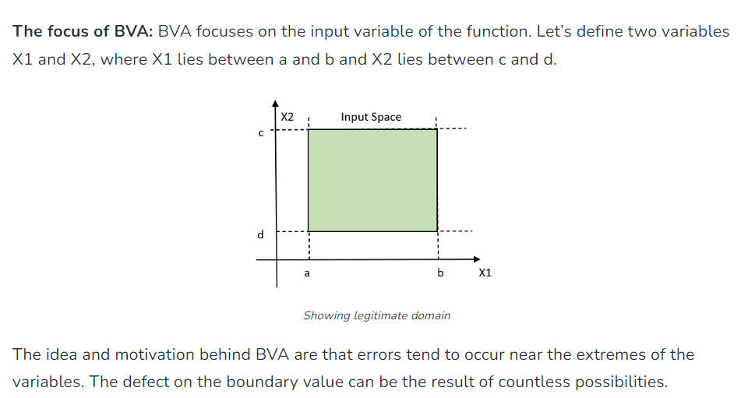

Equivalence Class Partitioning

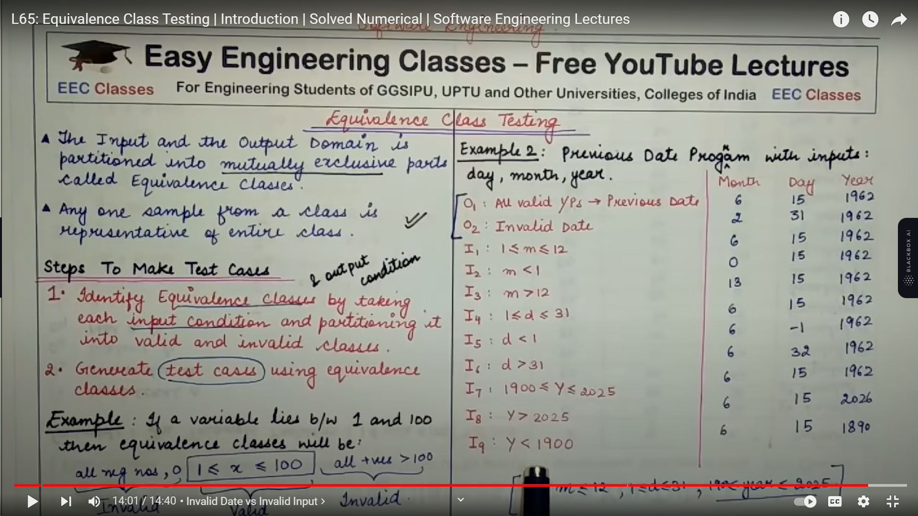

State Table Based Testing

<https://www.geeksforgeeks.org/state-transition-testing/>

Here's an explanation of state table-based testing with an example:

**1. Identify the States:**

First, you need to identify all the possible states that the system or software can be in. These states represent the different modes or conditions the system can assume during its operation. Each state should have a clear and well-defined purpose.

**2. Define the Transitions:**

Next, define the transitions between these states. Transitions represent the actions or events that trigger a change from one state to another. You should specify what conditions or events cause the system to move from one state to another.

**3. Create a State Table:**

Once you've identified the states and transitions, create a state table. This table typically has rows for states and columns for transitions. Each cell in the table indicates what action or behavior is expected when a specific transition occurs in a particular state. It can also include additional information, such as expected outputs or error conditions.

**Example: Elevator Control System**

Let's consider an example of an elevator control system:

**States:**

1. Idle

2. Moving Up

3. Moving Down

4. Stopped

**Transitions:**

- Transition 1: User presses the "Up" button

- Transition 2: User presses the "Down" button

- Transition 3: Elevator reaches a floor

- Transition 4: Emergency stop button pressed

**State Table:**

| State | Transition 1 | Transition 2 | Transition 3 | Transition 4 |

|---------------|----------------|----------------|----------------|----------------|

| Idle | Moving Up | Moving Down | Idle | Stopped |

| Moving Up | Moving Up | - | Moving Up | Stopped |

| Moving Down | - | Moving Down | Moving Down | Stopped |

| Stopped | Moving Up | Moving Down | Idle | Stopped |

In this state table:

- If the elevator is in the "Idle" state and a user presses the "Up" button (Transition 1), it should transition to the "Moving Up" state.

- If the elevator is "Stopped" and a user presses the "Down" button (Transition 2), it should transition to the "Moving Down" state.

- When the elevator is "Moving Up" and reaches a floor (Transition 3), it should stay in the "Moving Up" state unless there is a button press for another floor.

- If the "Emergency stop" button is pressed (Transition 4) in any state, the elevator should transition to the "Stopped" state.

This state table serves as a clear reference for testing the elevator control system to ensure that it behaves correctly in different states and transitions, helping identify potential issues and verifying that the system follows the specified logic.

Cause effect based testing

<https://www.geeksforgeeks.org/cause-effect-graphing-in-software-engineering/>



Error Guessing Technique

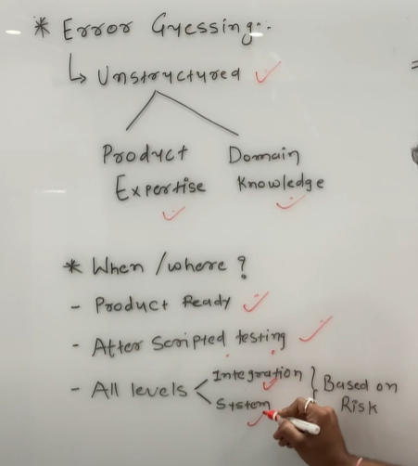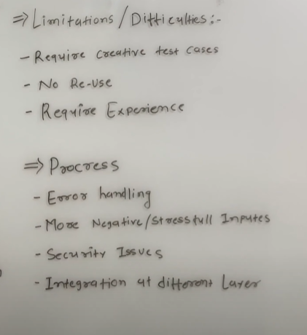

**Error Guessing** is an informal software testing technique where testers use their experience, intuition, and knowledge to identify and target areas of a software application that are likely to contain defects or errors. This technique relies on the tester's skill and insight rather than following predetermined test cases or formal test plans.

Here's how error guessing works:

1. **Domain Knowledge**: Testers rely on their domain knowledge and experience to guess where errors might be hiding. They often consider the specific domain of the software, the technology stack, and potential trouble areas based on their expertise.

2. **Exploratory Testing**: Testers explore the software application freely, using a variety of inputs and interactions. They do not follow a script or predefined test cases but instead try out different scenarios based on their intuition.

3. **Ad Hoc Testing**: This technique is often ad hoc in nature. Testers may focus on certain parts of the application, features, or inputs that seem complex or risky.

4. **Edge Cases**: Testers pay attention to edge cases and unusual conditions that might not be covered in standard test cases. These could include boundary values, rare user actions, or combinations of actions that might not have been anticipated.

5. **Negative Testing**: Testers actively look for situations where the application should fail or produce an error. This can include inputting invalid data, overloading the system, or trying to provoke unexpected behavior.

6. **Varying Inputs**: Testers use different inputs, often outside the typical or expected use cases, to uncover unexpected issues. They might try unusual combinations of inputs or interactions.

7. **Intuition**: Error guessing relies on the tester's intuition, hunches, and gut feeling. Testers with experience in the domain and software testing can often identify potential problem areas that others might miss.

It's important to note that error guessing is not a replacement for more structured testing techniques like equivalence partitioning, boundary value analysis, or test case design based on requirements. Instead, it complements these techniques. Testers use error guessing to catch issues that might not be covered by formal testing processes and to take a more exploratory and creative approach to finding defects.

Need for white box testing

1. Code verification
2. Identification of logical issues
3. Optimization
4. Security testing
5. Unit Testing
6. Early Detection of issues

1. **Code Verification**: White box testing allows for a thorough examination of the code to ensure that it is implemented correctly according to the design and requirements. This helps in verifying the accuracy of the code.

2. **Identification of Logical Errors**: White box testing can uncover logical errors, such as incorrect conditional statements, infinite loops, or dead code that could lead to system failures or vulnerabilities.

3. **Code Coverage**: It ensures that all paths within the code are tested, helping to achieve high code coverage. This helps in identifying areas of the code that are not exercised by other testing methods, such as black box testing.

4. **Security Testing**: White box testing is crucial for security testing. It can reveal vulnerabilities like SQL injection, buffer overflows, and other security weaknesses that may not be apparent through black box testing alone.

5. **Optimization**: It can help in optimizing code for efficiency and performance. By analyzing the internal code structure, potential bottlenecks or areas for improvement can be identified.

6. **Unit Testing**: White box testing is often used for unit testing, which involves testing individual components or functions. Unit testing helps in ensuring the reliability and correctness of each piece of code before they are integrated into the larger software system.

7. **Compliance and Standards**: In some industries, software must adhere to strict regulatory standards and compliance requirements. White box testing helps in demonstrating that the code follows these standards.

8. **Early Detection of Issues**: White box testing is performed at the development stage. By detecting and fixing issues early in the development cycle, it can save time and resources by preventing defects from propagating through the system.

9. **Debugging**: White box testing is a valuable tool for debugging, as it can pinpoint the exact location of errors or problems within the code, making it easier for developers to fix them.

10. **Continuous Integration**: In continuous integration and continuous delivery (CI/CD) pipelines, white box testing is often used to automatically test code changes as they are integrated into the codebase.

11. **Risk Mitigation**: By thoroughly examining the internal code, white box testing helps in identifying and mitigating risks associated with code quality, performance, and security.

Logic Coverage Criteria

1. Statement coverage
2. Branch coverage
3. Path coverage

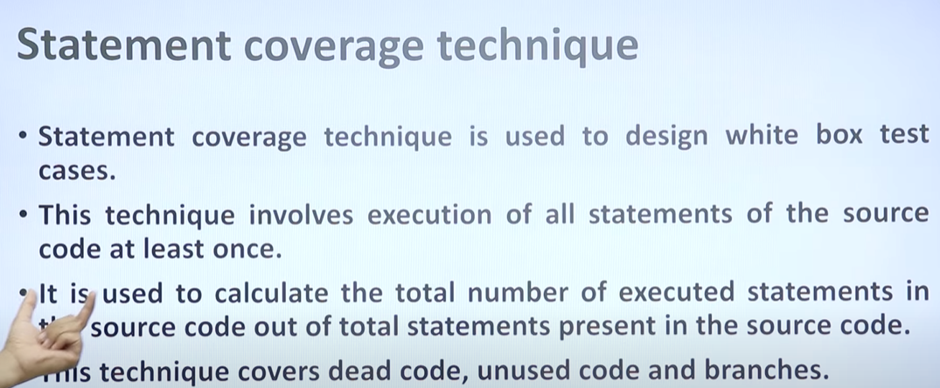

Basis Path Testing

**Basis Path Testing** is a white-box testing technique used to systematically design test cases for a software application by examining the control flow of the program. It is primarily used for structured programming languages and is focused on achieving high code coverage.

The basis path testing method involves the following steps:

1. **Control Flow Graph (CFG) Construction**: To perform basis path testing, you first construct a Control Flow Graph (CFG) for the software. A CFG is a graphical representation of the program's control flow, showing the various paths that can be taken through the code.

2. **Cyclomatic Complexity Calculation**: The cyclomatic complexity is a metric used to quantify the complexity of the software. It is calculated based on the CFG and helps determine the number of test cases required. The formula for cyclomatic complexity is:

```

V(G) = E - N + 2P

```

Where:

- `V(G)` is the cyclomatic complexity.

- `E` is the number of edges in the CFG.

- `N` is the number of nodes in the CFG.

- `P` is the number of connected components in the CFG.

3. **Identifying Independent Paths**: The cyclomatic complexity helps identify the number of independent paths through the software. These paths are usually associated with different combinations of decisions or control structures within the code.

4. **Generate Test Cases**: For each independent path, you generate test cases that exercise that path. These test cases are designed to ensure that all parts of the code are executed at least once.

Basis path testing is beneficial because it systematically ensures that all logical paths through the code are tested. It helps in achieving a high level of code coverage and can reveal issues related to control flow and logical errors. However, it can be complex and time-consuming, particularly for larger and more complex software systems.

The advantages of basis path testing include:

- Comprehensive testing: It helps achieve high code coverage, ensuring that different code paths are exercised.

- Early detection of control flow issues: It can identify problems related to control structures, such as loops and conditional statements.

- Effective for complex software: It is particularly useful for software with intricate control flow logic.

However, there are also some challenges and limitations associated with basis path testing:

- Time and effort: Generating test cases for all paths can be time-consuming and may not be practical for large applications.

- Doesn't address all testing aspects: While it covers code paths, it may not be sufficient to address other aspects like input validation or integration testing.

- Assumes a single entry and exit point: It assumes a single entry point and a single exit point in the program, which may not hold true for all types of software.

Basis path testing is one of several white-box testing techniques used in software testing to ensure code reliability and correctness. It is often used in conjunction with other testing methods to provide comprehensive test coverage.

LOOP TESTING

(control structure testing)

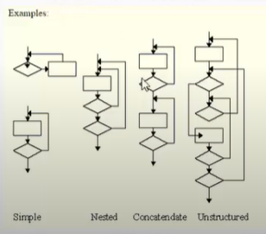

Loop Testing is a type of white-box testing technique that focuses on testing the control flow within loops in a software program. It aims to identify defects, errors, and issues related to the proper functioning of loops. Loops are an integral part of software code, and they can be a source of various types of problems, such as infinite loops, off-by-one errors, or incorrect loop conditions.

Data Flow Testing

Data Flow Testing is a type of structural testing. It is a method that is used to find the test paths of a program according to the locations of definitions and uses of variables in the program. It has nothing to do with data flow diagrams.

Data Flow Testing uses the control flow graph to find the situations that can interrupt the flow of the program. Directed to detect bugs that occur due to improper use of data variables.

Reference or define anomalies in the flow of the data are detected at the time of associations between values and variables.

Advantages of Data Flow Testing:

Data Flow Testing is used to find the following issues-

* To find a variable that is used but never defined,
* To find a variable that is defined but never used,
* To find a variable that is defined multiple times before it is use,
* Deallocating a variable before it is used.

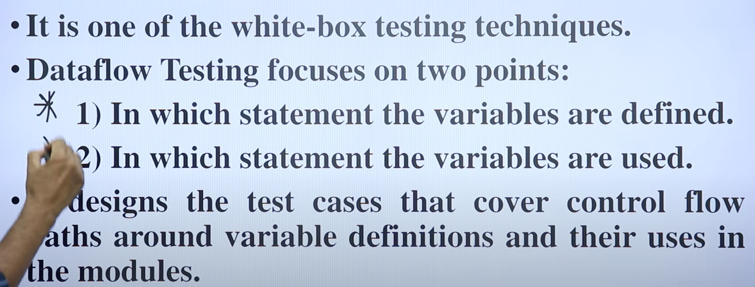

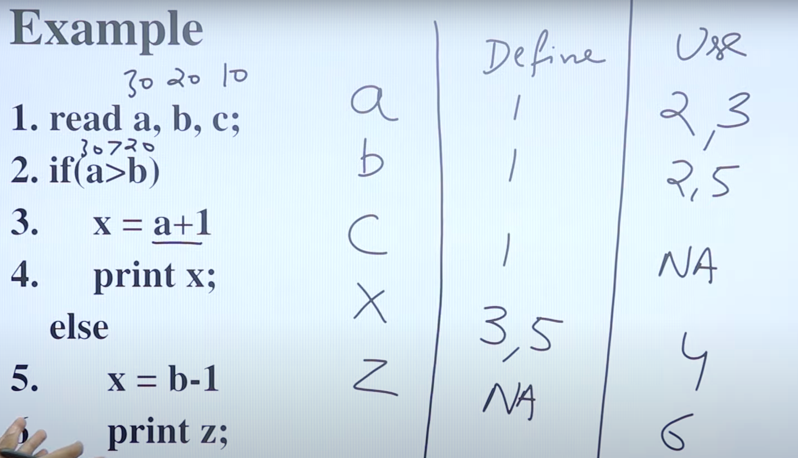

Disadvantages of Data Flow Testing

* Time consuming and costly process
* Requires knowledge of programming languages

Mutant Testing

It focuses to help the tester develop effective tests or locate weaknesses in the test data used for the program.

Mutation testing can be applied to design models, specifications, databases, tests, and XML. It is a structural testing technique, which uses the structure of the code to guide the testing process. It can be described as the process of rewriting the source code in small ways in order to remove the redundancies in the source code.

Objective of Mutation Testing:

The objective of mutation testing is:

1. To identify pieces of code that are not tested properly.
2. To identify hidden defects that can’t be detected using other testing methods.
3. To discover new kinds of errors or bugs.
4. To calculate the mutation score.
5. To study error propagation and state infection in the program.
6. To assess the quality of the test cases.

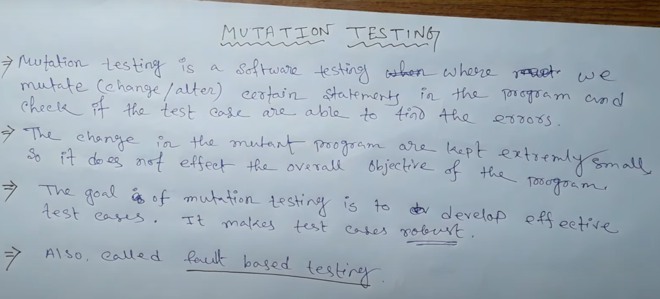

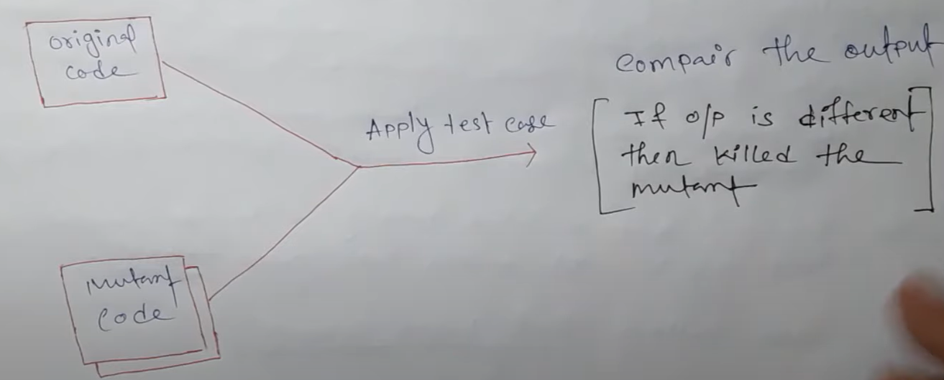

1. Value mutation
2. Decision mutation
3. Statement mutation

Mutation score=killedmutant/total number of mutations *100

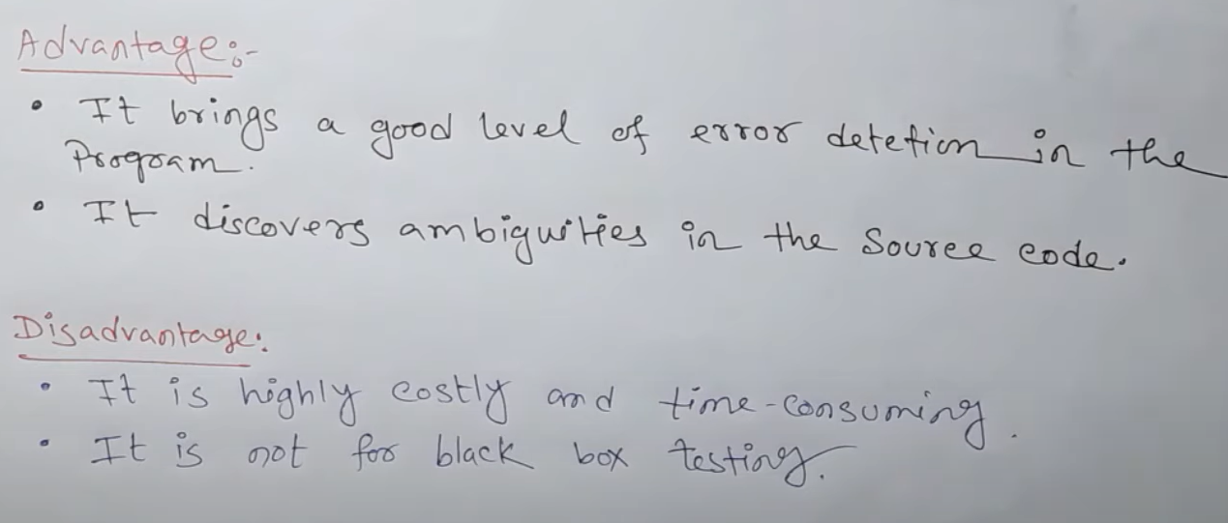

Static Testing

<https://www.geeksforgeeks.org/software-testing-static-testing/>